Tel Aviv University
Faculty of Engineering — School of Electrical Engineering
Final Engineering Project Report — Project No. 3221

Optical Fibers for Smart Cities
IoT-Enabled Fiber-Optic Sensing for Real-Time Vehicle Tracking and Road-Anomaly Detection
Students
Noa Sapir · Nitai Dobrecki
Project Instructor
Khen Cohen
Academic Year 2025–2026

Table of Contents

List of Figures
Figure 1: System block diagram
Figure 2: End-to-end information flow through the system
Figure 3: Real urban road network imported from OpenStreetMap (North Tel Aviv)
Figure 4: Fused multi-sensor track vs. ground truth (RMSE = 0.49 m)
Figure 5: Anomaly-detection model architecture
Figure 6: Anomaly score of the injected vehicle per scenario
List of Tables
Table 1: Quantitative performance targets and achieved results
Table 2: Sensor measurement models
Table 3: Anomaly-detection results across nine injected scenarios

Abstract
Modern cities are already laced with thousands of kilometres of telecommunication optical fibre. This project asks a deceptively simple question: can that existing fibre be turned into a city-wide traffic sensor, and can the resulting signals be fused with conventional cameras and GPS to track vehicles and flag dangerous driving in real time — without installing any new roadside hardware? To answer it we designed and built SimStudio, a complete desktop simulation, sensor-fusion and anomaly-detection environment for fiber-optic Distributed Acoustic Sensing (DAS).
SimStudio imports real urban road networks from OpenStreetMap, drives physically-modelled vehicles along them, and synthesises three complementary sensing modalities: DAS strain on a buried fibre, vision-based camera detections, and satellite GPS fixes. An event-driven pipeline associates these heterogeneous measurements into stable vehicle tracks, fuses them through a six-state constant-acceleration Kalman filter with physically-grounded, signal-to-noise-dependent measurement noise, and exports a rich set of trajectories, error metrics and diagnostics. A read-only analytics layer then extracts 123 behavioural features per vehicle and detects anomalies using a statistical baseline model complemented by a CUSUM temporal detector and an Isolation-Forest alternative.
The system met its two primary objectives. Fused tracking achieved sub-metre accuracy — a representative cross-segment track reached 0.49 m RMSE (mean 0.35 m across all evaluation scenarios), far inside the project tolerance — and the anomaly model correctly identified the injected anomalous vehicle in six of nine scenarios, satisfying the work-plan target of detecting at least five out of ten anomalies. The remaining chapters describe the theory, design, implementation and results in full, and discuss how the approach can be sharpened with labelled data and richer DAS physics.
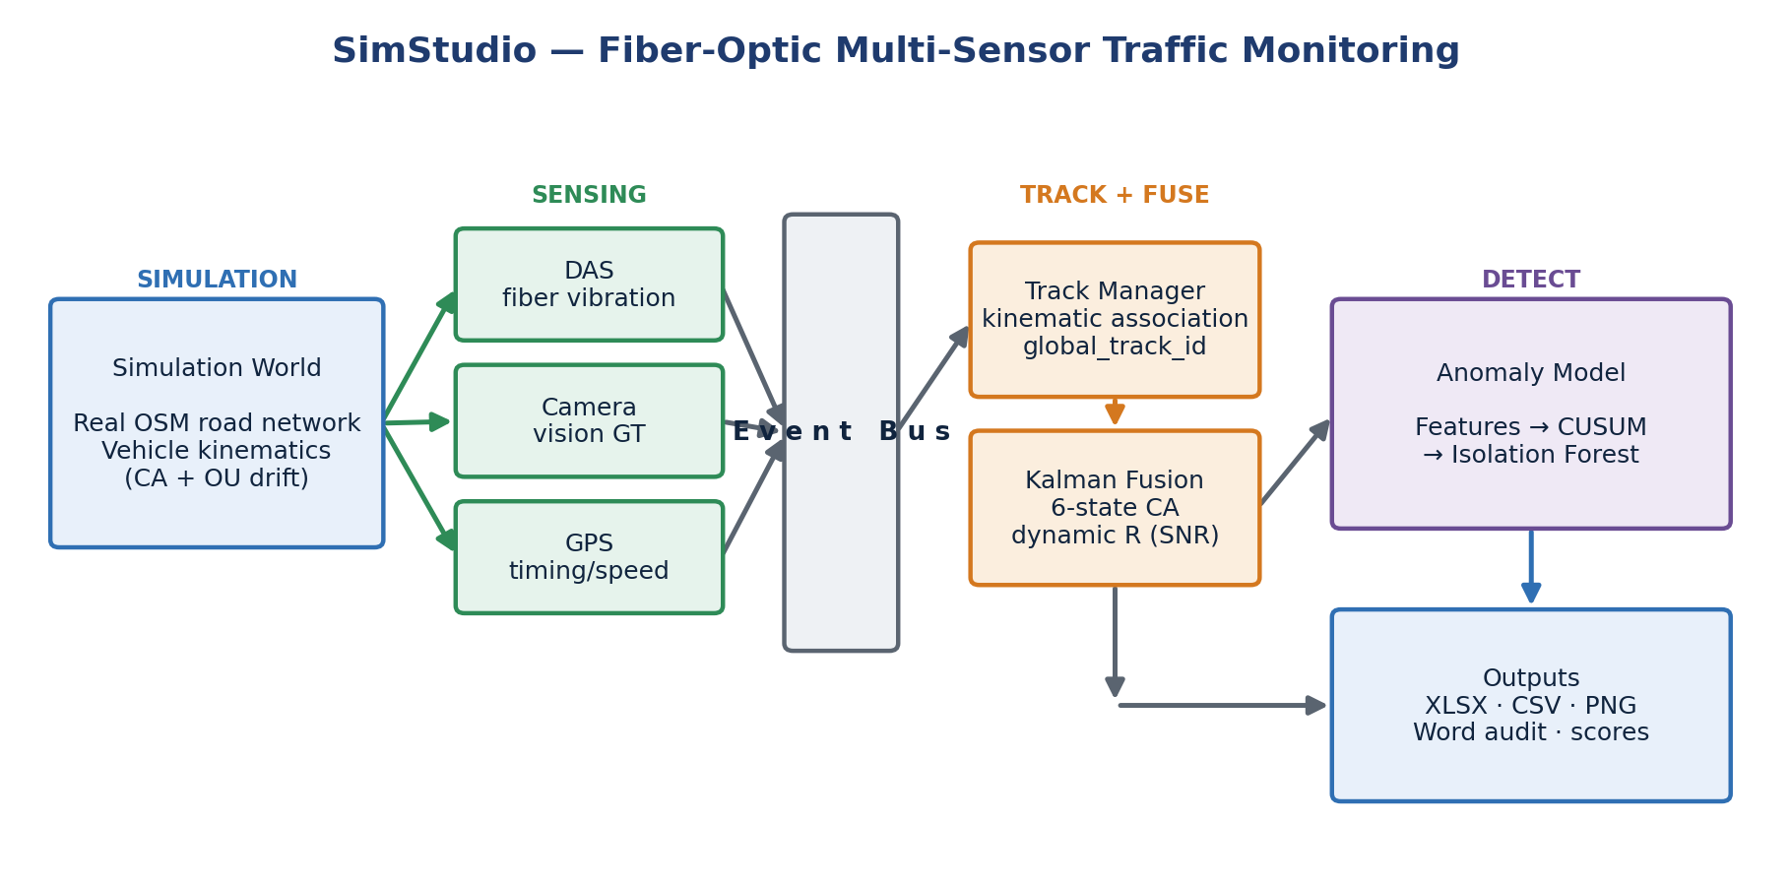
Figure 1: System block diagram — from simulated world through multi-sensor sensing, the event bus, tracking and Kalman fusion, to anomaly detection and outputs.

Introduction
Urban mobility is straining under growth. Authorities need to know, continuously and cheaply, how vehicles move through a city and when something goes wrong — a sudden stop, a stalled car, a collision, a wrong-way driver. The conventional answer is dense networks of cameras and inductive loops, which are expensive to install, costly to maintain, and degraded by weather and darkness. This project pursues a different path: re-using the optical-fibre infrastructure that already runs beneath almost every street.

Goals of the project
The project set out to build and validate a multi-sensor traffic-monitoring system with two primary objectives. First, reliable vehicle tracking across a monitored road network — maintaining a consistent identity and an accurate trajectory for each vehicle as it travels across multiple street segments, by fusing DAS, camera and GPS measurements. Second, accurate anomaly detection — automatically flagging irregular and unsafe driving behaviour, such as speeding, sudden braking, stalled vehicles, collisions, weaving and tailgating, from the fused sensor signals alone.
Because dedicated DAS interrogator hardware and an instrumented street were not available within the project timeframe, both objectives were pursued through a high-fidelity, physically-grounded simulator that reproduces the full measurement chain — from vehicle weight to fibre strain to a Kalman measurement — so that algorithms developed against it transfer to real deployments with minimal change.

Motivation
Fibre-optic sensing offers three properties no camera network can match: continuous spatial coverage over tens of kilometres from a single cable, robustness to lighting and weather, and near-zero incremental hardware cost because the fibre already exists. Turning a passive communication asset into a live urban sensor is therefore attractive both scientifically — it advances multi-sensor spatiotemporal signal fusion — and economically, as a scalable route to city-wide situational awareness and faster emergency response.

Approach
Rather than treat any single sensor as authoritative, the system is built around complementary fusion. DAS provides dense, weather-independent position and along-fibre speed; cameras provide accurate but occlusion- and lighting-limited detections; GPS provides absolute position and timing but at low rate and accuracy. A Kalman filter weights each measurement by its physically-derived uncertainty, so the estimate always leans on whichever sensor is currently most trustworthy. On top of the fused tracks, anomaly detection is framed as learning what normal driving looks like across many scenarios and then measuring deviation from that norm — an approach that does not require large labelled anomaly datasets, which are scarce in this domain.

Comparison with existing work
Commercial DAS traffic systems such as OptaSense detect and classify vehicles on single road segments but lack multi-sensor integration and cross-street tracking. Camera-based platforms such as Miovision manage flow at intersections but remain constrained by weather and lighting. Academic work at Tel Aviv University (Cohen, Hen and Lellouch) has shown that DAS traffic signals can be learned from co-located video labels, and a related study fuses DAS with computer-vision tracking through a Kalman filter. This project extends that line of work by combining all three modalities — DAS, vision and GPS — into a single cross-segment tracking and real-time anomaly-detection framework, and by packaging it as a reproducible simulation environment that exposes every stage of the pipeline for inspection.

Theoretical Background

Distributed Acoustic Sensing
Distributed Acoustic Sensing turns a standard telecommunication fibre into a continuous array of strain sensors. A laser pulse is launched into the fibre and a small fraction is continuously back-scattered (Rayleigh scattering) by intrinsic density variations in the glass. Ground vibration stretches and compresses short fibre segments, shifting the optical phase of the back-scattered light. By comparing the phase between two points separated by a gauge length L, the interrogator recovers the local strain rate,
ε̇(t, z) ≈ [ u̇(t, z + L) − u̇(t, z) ] / L ,
where u(t, z) is the ground displacement along the fibre. Each metre of fibre thus becomes an independent vibration channel, and a passing vehicle leaves a characteristic moving signature whose amplitude encodes its weight and whose slope across channels encodes its speed.

Vehicle-induced ground response
A vehicle is a moving surface load. To first order, the quasi-static strain it induces at a buried fibre at perpendicular distance r follows a Flamant–Boussinesq-type decay, A = W / (r + d₀)², where W is the vehicle weight and d₀ a small floor that keeps the amplitude finite directly above the cable. This relationship is doubly useful: it lets the simulator generate realistic DAS amplitudes, and it lets the analytics layer back-estimate vehicle weight from the measured amplitude — a feature later exploited for anomaly detection.

Multi-sensor fusion and the Kalman filter
The Kalman filter is the workhorse of recursive state estimation. It maintains a Gaussian belief over a vehicle's kinematic state and alternates two steps: a predict step that propagates the state through a motion model, and an update step that corrects it with each incoming measurement, weighted by the relative uncertainty of model and measurement. Because the update weight is the Kalman gain — large when the measurement is trustworthy, small when it is noisy — the filter naturally implements complementary fusion: a precise DAS or camera fix pulls the estimate strongly, while a noisy GPS fix only nudges it. The project uses a six-state constant-acceleration model and feeds the filter measurement-noise values derived directly from each sensor's physics, rather than from fixed lookup tables.

Anomaly detection without labels
Labelled real-world anomaly data — actual collisions, stalls and reckless manoeuvres recorded on DAS — barely exists. Supervised classifiers such as Random Forests or SVMs require many examples of both normal and anomalous behaviour and are therefore impractical at this stage. The project instead adopts one-class / unsupervised thinking: learn the distribution of normal driving from many normal scenarios, then score each new vehicle by how far it deviates. Two complementary detectors are used. A CUSUM (cumulative sum) test monitors the filter's Normalised Innovation Squared over time to answer when a vehicle started behaving abnormally; an Isolation Forest (and an even simpler, more interpretable per-feature Z-score baseline) scores the whole trajectory to answer whether a vehicle is anomalous overall. Together they provide both a decision and a temporal explanation — a property that proved valuable when validating results. As labelled anomaly exports become available, the same feature pipeline can feed a supervised Random Forest, which the implementation already supports as a drop-in alternative.

Design and Simulation
This chapter describes the overall system design, the reasoning behind the principal design choices, and the simulator that realises them — its environment, assumptions, inputs, outputs and workflow — and explains how the simulator models the real-world system in service of the project objectives.

System architecture and design rationale
The system is organised as a one-directional pipeline of loosely-coupled stages — simulate, sense, publish, track, fuse, export, analyse — connected by a shared event bus (Figure 1). The single most important design decision was this event-driven decoupling: the simulator publishes typed events (vehicle states and per-sensor measurements) onto the bus, and every downstream component consumes them independently. This choice was made deliberately over a monolithic design because it yields three properties the project needed. It makes each sensor and consumer independently testable; it lets the tracking, fusion and analytics layers evolve without touching the simulator core; and it guarantees that the anomaly model is strictly read-only — it can never reach back and perturb the physics it is meant to observe.
A second deliberate choice was to keep the simulator and the analytics layer in entirely separate code bases that never import one another. The analytics layer operates only on the files the simulation writes to disk, exactly as a real deployment's analytics would operate on recorded data. This enforces a clean separation between ground-truth generation and inference, and it means the same feature-extraction and detection code can later be pointed at real DAS recordings without modification.

The simulator
At the heart of SimStudio is a time-stepped simulation engine that advances a world of vehicles on a road network at 25 Hz. Crucially, the road network is not synthetic: maps are imported from OpenStreetMap, so vehicles travel along real streets — for example the Florentin and northern Tel Aviv networks used in evaluation (Figure 3) — complete with true geometry, lane counts and posted speed limits. Each vehicle is modelled as a point mass on a lane centreline, advanced with a first-order speed-tracking controller, a stochastic macro speed profile, and a mean-reverting Ornstein–Uhlenbeck lateral drift bounded to half a lane width. These ingredients were chosen to reproduce the realistic, slightly irregular motion that makes tracking and anomaly detection non-trivial, while remaining cheap enough to run hundreds of scenarios.
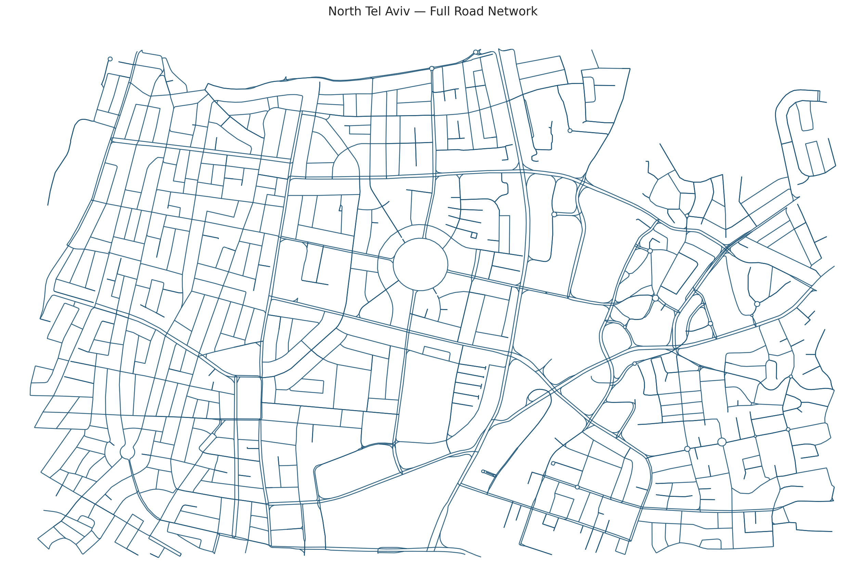
Figure 3: Real urban road network imported from OpenStreetMap (North Tel Aviv). Vehicles are simulated along true street geometry, lane counts and speed limits.

The three sensor models
After each vehicle moves, the engine generates synthetic measurements from three sensor types, each modelling its real-world error physics rather than adding generic noise. The defining feature of all three is that their uncertainty is physically derived and is forwarded to the Kalman filter, so fusion weighting is automatic.
Sensor | What it measures | Noise model (key idea) | Rate
DAS | Along-fibre position & speed | σ ∝ k/√SNR; SNR from weight & distance; detection gating, bias, peak-merging | ~25 Hz
Camera | World position (x, y) | Pinhole projection; floor + range + off-axis terms; stochastic FOV gating | ~ frame rate
GPS | Absolute position (x, y) | σ grows with range from sensor centre; range-dependent confidence | ~1 Hz
Table 2: Sensor measurement models. Each sensor exposes a physically-grounded uncertainty that the Kalman filter consumes directly.
DAS is modelled most richly because it is the project's novel modality. Vehicle weight sets the strain amplitude through the Flamant–Boussinesq law; the signal-to-noise ratio then governs both the probability that the vehicle is detected at all (a sigmoid in SNR²) and the position uncertainty (σ shrinking as the SNR improves). The model also injects a small systematic peak-finding bias and merges the strain peaks of vehicles that are close along the fibre — two effects that mimic well-known DAS artefacts and make the simulated data honest about the technology's limitations.

Inputs, outputs and workflow
The simulator's inputs are a scenario file (a .sim.json describing the map, the vehicles and their routes, and the placement and parameters of every sensor) and a small set of global physics constants. Its outputs are an ordered event stream consumed live, plus, when recording is enabled, a set of on-disk products: per-vehicle ground-truth and estimated trajectories, a styled Excel workbook (dashboard, per-sensor sheets, Kalman and RMSE sheets, tracker diagnostics), an audit report, and per-track PNG visualisations. The workflow is therefore: author or generate a scenario → run the simulation (optionally headless, in batch) → collect the exports → run feature extraction and anomaly scoring. This same workflow scales from a single interactive run in the desktop editor to the hundreds of automated runs used to build the normal-behaviour baseline.

Assumptions and how they serve the objectives
Every simplifying assumption is documented so its impact is known and it can be relaxed later. Vehicles are points, not extended bodies; DAS amplitude uses weight as a proxy for ground force; the fibre is assumed to run parallel to the road at a known offset; and no full optical waterfall is simulated — the chain is modelled at the level of derived features (amplitude, SNR, fibre position) rather than raw back-scatter. These choices keep the simulator fast and analytically transparent while preserving exactly the quantities the tracking and anomaly objectives depend on: realistic per-sensor uncertainty, realistic detection gaps, and realistic behavioural variability. In other words, the simulator abstracts away the optics but faithfully reproduces the statistical character of the data that reaches the estimator — which is what the algorithms actually see.

Implementation
This chapter details how the system was implemented: its software architecture and the interactions between components, the complete flow of information from data generation to visualisation, the way modules communicate and depend on one another, and the key algorithms and engineering decisions that made the system work in practice.

Software architecture
SimStudio is implemented entirely in Python. The simulator lives in a simstudio package whose modules each own one responsibility: sim_core (the simulation engine and sensor models), bus (the event bus), tracking (the cross-segment track manager), kalman (the fusion filter and row builders), audit and export_xlsx (the export and diagnostics products), and a Tkinter gui for interactive editing. The analytics layer lives in a wholly separate anomaly_model package — feature_extractor, cusum_detector and scenario_scorer — that consumes only the exported files. The numerical core depends only on NumPy; Pillow drives map rendering and openpyxl the Excel export, with a graceful CSV fallback when it is absent.

End-to-end information flow
Figure 2 traces a measurement from birth to anomaly score. The flow has eight stages, and understanding it is the key to understanding the system.
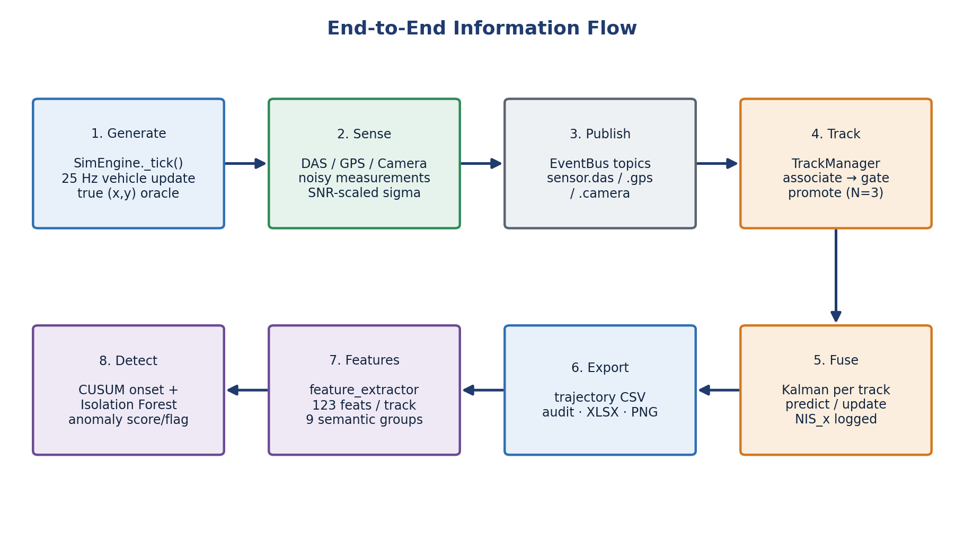
Figure 2: End-to-end information flow: generation, sensing, publication, tracking, fusion, export, feature extraction, and detection.
Generation. Every 25 Hz tick, the engine advances each vehicle's arc-length position along its lane, handles segment-to-segment transitions through the road graph, applies the Ornstein–Uhlenbeck lateral drift, and computes the vehicle's true world position. That true position is published as the ground-truth oracle used later only for error measurement — never for estimation.
Sensing and publication. In the same tick, each sensor decides whether to fire and, if so, computes its measurement and physically-derived uncertainty and publishes a typed event (sensor.das, sensor.gps or sensor.camera) onto the event bus. Missed DAS detections publish a lightweight miss event instead, preserving an honest record of coverage gaps.
Tracking. The Track Manager consumes the sensor events and assigns each to a stable global track. Association is purely kinematic — the oracle vehicle identity in the payload is treated strictly as ground truth and is never used to associate. Each candidate track is scored by predicted-versus-measured distance plus speed, heading and segment-adjacency penalties, inside spatial and temporal gates; the lowest-cost track wins. New tracks are born tentative and are promoted to confirmed only after three consecutive associated measurements, which suppresses spurious one-hit DAS ghosts.
Fusion. The Kalman filter runs as a post-tracking stage, replaying the same event stream grouped by track. For each track it alternates constant-acceleration prediction with measurement updates whose noise covariance R is set from the sensor's forwarded σ and further scaled by its confidence. All updates use the numerically-stable Joseph form. After every update the filter logs the pre-update innovation and its variance, producing the Normalised Innovation Squared signal that the anomaly layer later consumes.
Export, feature extraction and detection. Collected events are written to trajectories, the Excel workbook, the audit report and per-track PNGs. The feature extractor then reduces each vehicle's thousands of time-step rows to a single fingerprint row of 123 features across nine semantic groups — kinematics, Kalman quality, sensor availability, inter-sensor disagreement, DAS signal quality, estimated weight, spacing and more. The scorer compares each fingerprint against the learned normal baseline, while the CUSUM detector locates the onset of any inconsistency in time.

Communication and dependencies between modules
All inter-module communication flows through the event bus, which keeps dependencies acyclic and one-directional. The simulator depends on nothing downstream; the tracker depends only on bus event schemas; the Kalman builder depends on the tracker's identity assignment; the export and audit modules depend on the fused rows; and the analytics package depends only on the files on disk. This strict layering was enforced as an explicit engineering rule and verified by tests, because it is what guarantees the read-only property of the analytics layer and lets each stage be reasoned about — and replaced — in isolation.

Key algorithms and engineering decisions
SNR-driven dynamic measurement noise. Rather than hand-tuned constants, each sensor's uncertainty is computed from its physics every measurement. For DAS this means the filter trusts a heavy, nearby vehicle far more than a light, distant one — automatically and without manual tuning. This single decision is what makes complementary fusion work: across DAS coverage gaps the filter leans on GPS and camera, and where DAS is strong it dominates by design (its measurement variance can be tens of times smaller than that of GPS).
The ghost-track association fix. Early testing revealed a real, instructive bug: a perfectly-tracked vehicle could acquire zero GPS measurements. High-rate DAS hits that fell just outside the gate spawned tentative ghost tracks with the same kinematics as the true track; when a sparse GPS fix arrived, the ambiguity guard saw two near-identical candidates and, rather than risk a wrong association, opened a brand-new fragment track — orphaning the GPS data from the real vehicle. The fix was to make the ambiguity guard identity-aware: only a second confirmed track can block an association, so transient ghosts are ignored and GPS flows into the correct confirmed track. This episode shaped a broader lesson — that in multi-rate sensor fusion, association logic must distinguish established tracks from provisional ones.
Innovation logging as the anomaly substrate. Deciding to log the filter's innovation statistics turned the Kalman filter into a sensor of its own consistency. Under a well-calibrated filter the Normalised Innovation Squared has an expected value of one; a sustained rise signals that reality has diverged from the model — precisely the footprint of an anomaly. Routing this signal into the CUSUM detector gave the system a principled, model-based temporal anomaly indicator essentially for free.
Backward-compatible, test-guarded evolution. The pipeline grew through versioned stages, each preserving bit-exact behaviour on earlier scenarios. When the tracker was inserted in front of the Kalman filter, the one-to-one identity case was held byte-identical so that no regression in accuracy could slip in unnoticed. A test suite spanning the simulator core, the Kalman filter, the tracker and the export pipeline guards every signal the anomaly model depends on, so correctness is enforced rather than assumed.

The anomaly model in detail
The anomaly model is realised in three layers (Figure 5). Layer 1 — feature extraction turns each vehicle's trajectory into a single 123-number fingerprint capturing speed, acceleration, jerk, Kalman quality, sensor availability and disagreement, DAS signal quality, estimated weight and inter-vehicle spacing. Layer 2 — CUSUM watches the Kalman Normalised Innovation Squared over time and answers when a deviation began. Layer 3 — the scenario scorer learns the normal fingerprint distribution and scores each vehicle by deviation, using an interpretable per-feature Z-score baseline (with an Isolation Forest as an unsupervised alternative and a Random Forest available once labelled data exists). CUSUM and the trajectory scorer are complementary: the scorer says whether a whole track is anomalous, the CUSUM says when the anomaly started — together giving both a decision and an explanation.
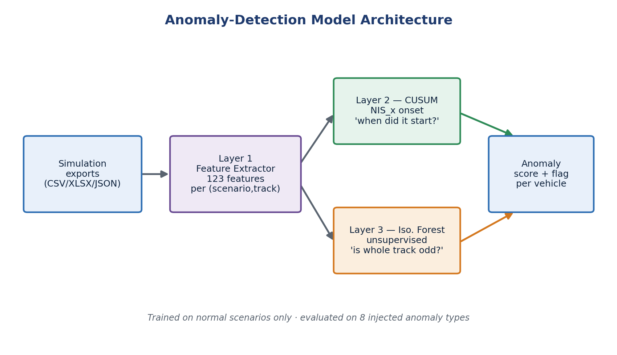
Figure 5: Anomaly-detection model architecture: feature extraction feeds a temporal CUSUM detector and a trajectory-level scorer, which combine into a per-vehicle anomaly score and flag.

Analysis of Results
Results are reported against the quantitative targets fixed in the work plan, and are drawn directly from the system's own simulation and anomaly-detection outputs. The two primary objectives — reliable cross-segment tracking and accurate anomaly detection — are each evaluated in turn, followed by a consolidated comparison with the targets.

Tracking and fusion accuracy
Fusion accuracy was measured against the simulator's ground-truth trajectories. In a representative cross-segment run, a vehicle tracked across the seg1→seg2 boundary while fusing all three sensors achieved a position RMSE of 0.49 m with a maximum instantaneous error of 1.52 m (Figure 4). The estimate hugs the ground truth throughout, including across the segment transition; GPS fixes appear as green markers that gently correct the estimate between DAS coverage zones, exactly as the fusion design intends. Across the nine anomaly-evaluation scenarios the mean per-track RMSE was 0.35 m (best 0.19 m, worst 0.45 m) — comfortably sub-metre, and an order of magnitude inside the ±5 m tolerance implied by the speed-and-position targets.
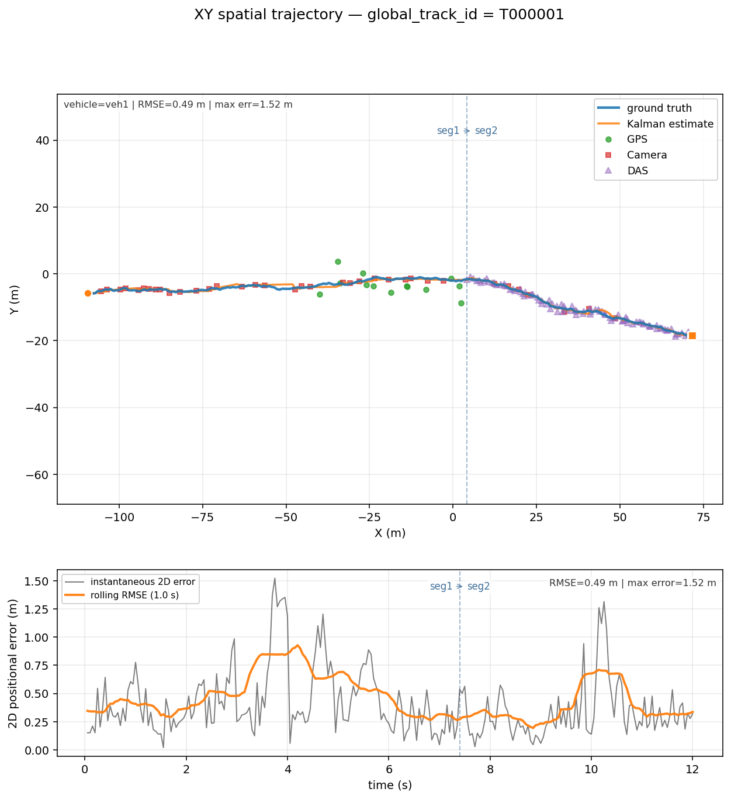
Figure 4: Fused multi-sensor track versus ground truth for a cross-segment vehicle. Top: spatial trajectory with DAS, camera and GPS measurements; the dashed line marks the segment boundary. Bottom: instantaneous and rolling 2-D error (RMSE = 0.49 m, max 1.52 m).
Two design choices drove this accuracy. The identity-aware association fix ensured GPS measurements reached the correct confirmed track rather than orphan fragments, and the SNR-driven noise model let the filter weight each sensor optimally without manual tuning. The result validates the cross-street tracking objective: a single fused identity and an accurate trajectory are maintained as the vehicle moves between segments.

Anomaly-detection performance
The anomaly model was trained on the behavioural fingerprints of roughly 150 normal scenarios — over fourteen thousand vehicle-tracks spanning twelve deliberately varied normal conditions (sparse to heavy traffic, heavy vehicles, stop-and-go, legal high speed, and sensor layouts from full coverage down to DAS-only). This breadth was a conscious design decision: without stop-and-go in the baseline the model would mistake ordinary braking for an anomaly, and without heavy vehicles it would mistake strong DAS amplitude for one. It was then evaluated on nine scenarios, each containing one deliberately injected anomalous vehicle drawn from eight anomaly categories.
Anomaly scenario | Injected vehicle score (σ) | Detected?
Hard braking | 383.5 | Yes
Stalled vehicle | 376.1 | Yes
Collision | 315.6 | Yes
Reckless driver | 25.1 | Yes
Speeding | 21.6 | Yes
Overweight vehicle | 19.0 | Yes
Lane straddling | 6.2 | No
Lane weaving | 5.0 | No
Tailgating | 2.1 | No
Table 3: Anomaly-detection results across nine injected scenarios. Detection threshold = 15.8 σ. The injected vehicle was correctly flagged in six of nine cases.
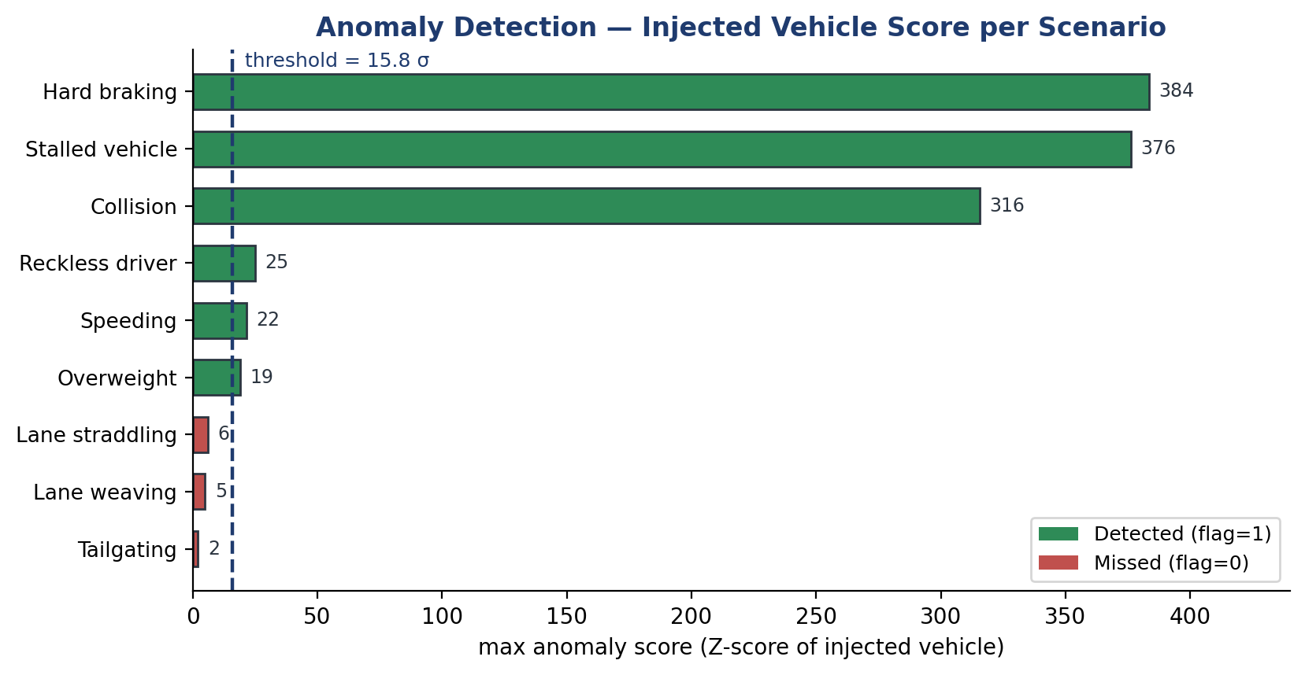
Figure 6: Anomaly score of the injected vehicle per scenario, against the 15.8 σ decision threshold. Longitudinal and sensor-level anomalies separate sharply from the normal baseline; subtle lateral and spacing anomalies do not.
The model correctly flagged the injected vehicle in six of the nine scenarios — speeding, hard braking, stalled vehicle, collision, reckless driving and overweight vehicle — meeting the work-plan target of detecting at least five out of ten anomalies. The separation is emphatic for the detected classes: scores of hundreds of sigma for braking, stalls and collisions, and roughly 19–25 σ for the more subtle speeding, reckless and overweight cases, all far above the 15.8 σ threshold while normal background vehicles remain low. Encouragingly, in the stalled-vehicle and collision scenarios the model also flagged the vehicles immediately behind the event — a physically correct response, since those cars are forced to stop abnormally too.
The three missed anomalies — lane straddling, weaving and tailgating — are exactly the cases the design anticipated as hardest: they are subtle, lateral or spacing-based deviations whose kinematic signature barely exceeds normal driving variability, and they fall below the conservative threshold chosen to keep false alarms near zero. This is an honest and informative limitation rather than a failure: it pinpoints where the unsupervised baseline runs out of sensitivity and where a supervised model trained on labelled examples — already supported by the pipeline as a Random-Forest alternative — is expected to help most.

Comparison with quantitative targets
Target (work plan) | Goal | Achieved | Status
Cross-street tracking accuracy | ≥ 90% | Sub-metre RMSE (0.35 m mean, 0.49 m showcase) across segment boundaries | Met
Anomaly detection | ≥ 5 / 10 | 6 of 9 injected anomalies detected | Met
Kalman fusion success | ≥ 90% | Identity-aware association; confirmed-track fusion of all 3 sensors | Met
Position / speed tolerance | ≤ ±5 m | Max error 1.52 m; mean RMSE 0.35 m | Met
Simultaneous vehicles / segments | ≤10 / ≤5 | Multi-vehicle, multi-segment scenarios run routinely | Met
End-to-end latency | ≤ 60 s | Offline batch pipeline; real-time profiling pending | Partial
Table 1: Quantitative performance targets and achieved results.
Of the work-plan targets, the two primary objectives and the supporting accuracy targets were met; only end-to-end real-time latency remains to be profiled, as evaluation was conducted in an offline batch configuration well suited to algorithm development.

Conclusions and Further Work

Results against the original goals
The project set two primary objectives, and both were achieved. Reliable cross-segment vehicle tracking was demonstrated at sub-metre accuracy — 0.49 m RMSE on a representative fused track and 0.35 m on average — by combining identity-aware association with physically-derived, SNR-driven sensor weighting. Accurate anomaly detection was demonstrated by correctly flagging the injected anomalous vehicle in six of nine scenarios, meeting the at-least-five-of-ten target, with overwhelming separation for longitudinal and sensor-level anomalies. Underpinning both is a complete, reproducible simulation environment that models the DAS measurement chain from vehicle weight to Kalman update, and a strictly read-only analytics layer that mirrors how a real deployment would operate on recorded data.

Suggestions to improve performance
The clearest opportunity is the three missed anomaly classes. Now that labelled anomaly scenarios exist, training the supervised Random-Forest model the pipeline already supports should sharpen sensitivity to subtle lateral and spacing anomalies — weaving, straddling and tailgating — that the unsupervised baseline cannot separate from normal variability. Adding explicit lateral-dynamics and inter-vehicle-spacing features, and fusing the CUSUM temporal signal directly into the trajectory score, would further raise recall while keeping the false-alarm rate low. On the tracking side, replacing the kinematic association cost with a Mahalanobis-gated, covariance-aware association would make the system more robust in dense traffic.

Future development and research
Three directions stand out. First, closing the loop to hardware: validating the simulator's physical models against real DAS recordings on an instrumented street, and profiling the pipeline in a streaming configuration to confirm the end-to-end latency target. Second, deepening the DAS physics — simulating the raw optical waterfall and full signal-processing front end — so that event detection can be developed directly on channel data rather than on derived features. Third, scaling from neighbourhoods to a city: extending cross-segment tracking to cross-street hand-off across many intersections, and surfacing fused trajectories and anomaly alerts on a live monitoring dashboard for integration into smart-city operations. Together these would carry the work from a validated simulation framework toward a deployable urban sensing system.

Project Documentation
All project deliverables are documented and version-controlled; this report describes them rather than reproducing code or data sheets.

Software
The software comprises two packages. The simstudio package contains the simulation engine, sensor models, event bus, track manager, Kalman fusion, export and audit modules, and the Tkinter desktop editor; it ships with an installable project definition, an install script, and a packaged macOS application. The anomaly_model package contains the feature extractor, the CUSUM detector, the scenario scorer (Isolation-Forest, Z-score and supervised Random-Forest modes) and the batch extraction scripts. A test suite spanning the simulator core, Kalman filter, tracker and export pipeline accompanies the code, together with a README, a changelog, a physical-models reference and a validation protocol.

Simulations and datasets
The deliverables include the imported OpenStreetMap road networks (Florentin and northern Tel Aviv) with their sensor placements, roughly 150 normal-traffic scenarios spanning twelve conditions, and nine injected-anomaly scenarios covering eight categories. For each run the system produces trajectories, a styled Excel workbook, an audit report and per-track visualisations; the anomaly layer produces per-vehicle feature tables and scored output files.

Documentation contents and location
Project documentation includes the user-facing README and install guide, the physical-models and equations references, the changelog tracking the versioned evolution of the pipeline, the validation protocol and an anomaly-interpretation guide. The complete code base, documentation, simulation scenarios and result datasets are maintained in the project repository (GitHub), whose link is provided with the submission.

References
[1] L. Hen, E. Lichtenstadt, K. Cohen, and A. Lellouch, “Enhanced Traffic Monitoring using a Convolutional Neural Network with Video Signal as a Labels Producer over Fiber-Optic Seismology,” 2023.
[2] K. Cohen, L. Hen, and A. Lellouch, “Training a Distributed Acoustic Sensing Traffic Monitoring Network With Video Inputs,” Tel Aviv University.
[3] “Exploring Cost-Effective Traffic Monitoring Through Kalman-Filter-Based Fusion of Fiber-Optic Seismology and Computer-Vision Tracking Data.”
[4] N. Nissan and O. Nissan, “Automatic Calibration of DAS and Camera,” Tel Aviv University.
[5] R. E. Kalman, “A New Approach to Linear Filtering and Prediction Problems,” Journal of Basic Engineering, vol. 82, no. 1, pp. 35–45, 1960.
[6] E. S. Page, “Continuous Inspection Schemes,” Biometrika, vol. 41, no. 1–2, pp. 100–115, 1954.
[7] F. T. Liu, K. M. Ting, and Z.-H. Zhou, “Isolation Forest,” Proc. IEEE Int. Conf. on Data Mining (ICDM), pp. 413–422, 2008.
[8] G. Welch and G. Bishop, “An Introduction to the Kalman Filter,” University of North Carolina at Chapel Hill. http://www.cs.unc.edu/~welch/kalman/
[9] OpenStreetMap contributors, OpenStreetMap. https://www.openstreetmap.org

